Lab 14: AWS Cloudwatch
Amazon CloudWatch is a monitoring and observability service provided by AWS. It helps you track the performance, usage, and health of your AWS resources and applications in real-time.
- Monitor application and infrastructure health
- Set alarms to auto-scale EC2 or send notifications
- Troubleshoot issues faster with centralized logs
- Visualize metrics in real-time dashboards
CloudWatch Works With:
- EC2 (CPU, disk, memory)
- Lambda
- API Gateway
- RDS, DynamoDB
- ECS, EKS, CloudTrail, and more
CLoudwatch works by
- Collecting Data: From AWS services, custom apps, or agents
- Storeing Data: Time-series metrics, logs
- Monitoring/Alerting: Dashboards, alarms, notifications
- Responding: Trigger auto-scaling or AWS Lambda functions

The AWS Cloudwatch Console looks like
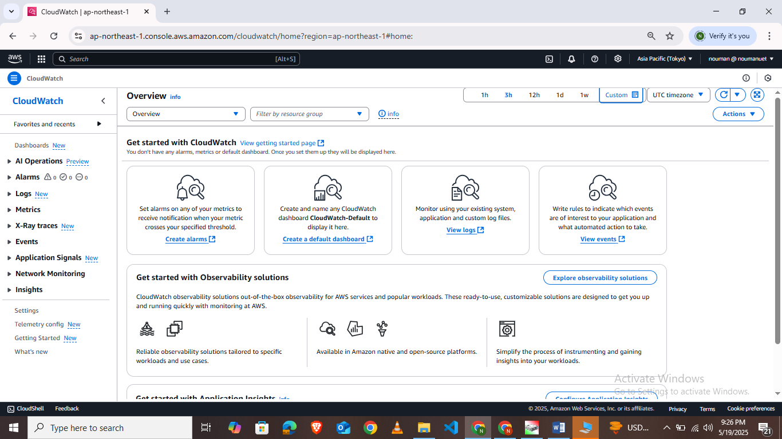

Attaching Cloudwatch to an ec2 instance:
- Launch an EC2 instance
- Attach an IAM the IAM role CloudWatchAgentServerPolicy to your EC2 instance
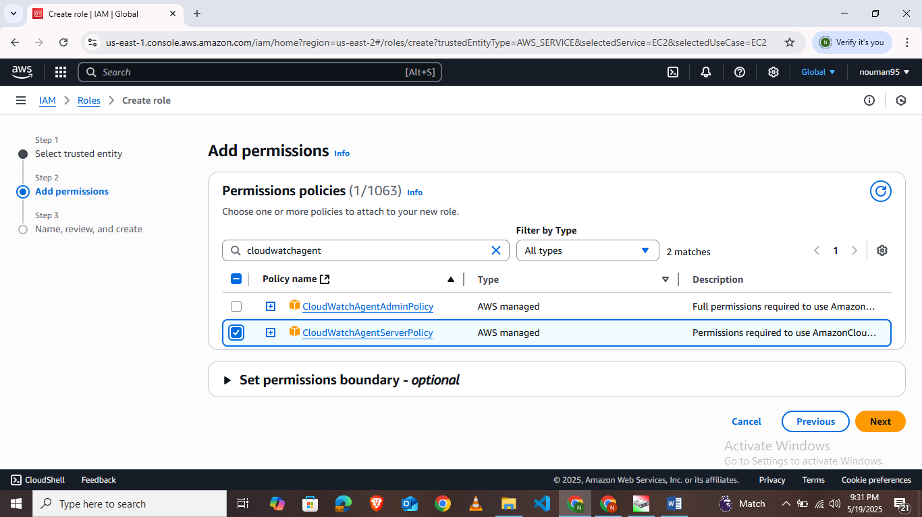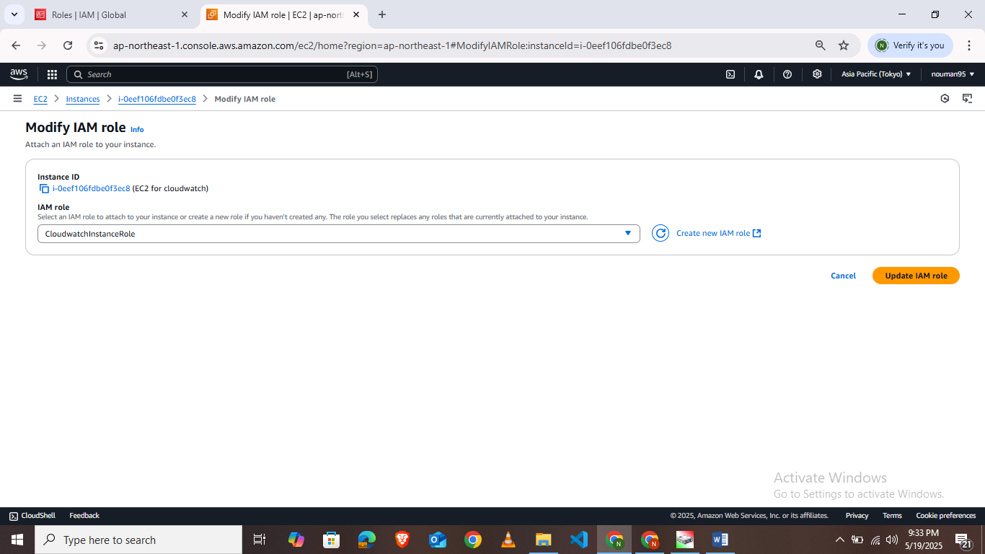
- Connect to your EC2 instance and install the cloudwatch agent by running following commands

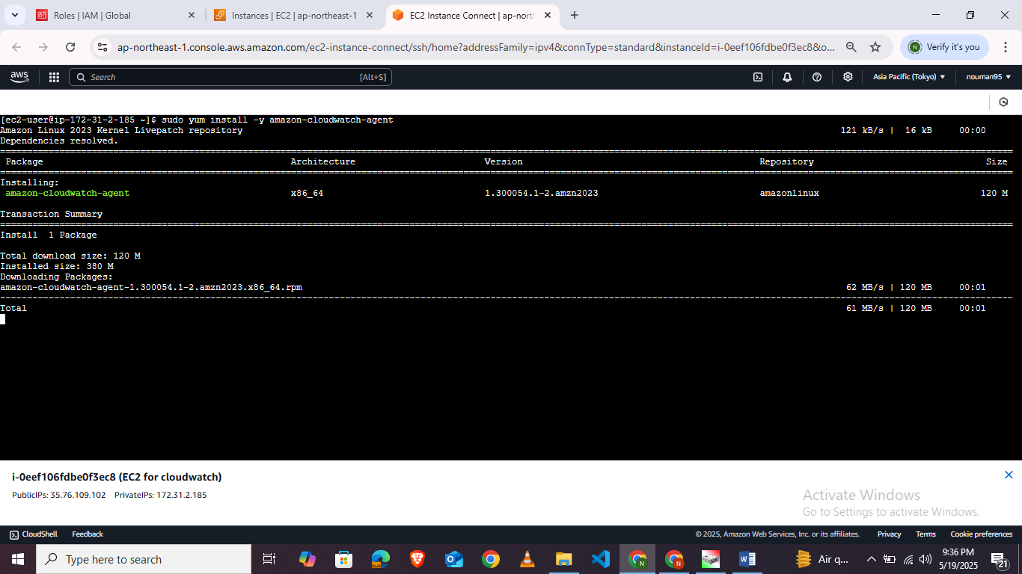
- Before running the CloudWatch agent on any servers, you must create one or more CloudWatch agent configuration files. The agent configuration file is a JSON file that specifies the metrics, logs, and traces that the agent is to collect, including custom metrics.Run the following command and answer the wizard questions
sudo /opt/aws/amazon-cloudwatch-agent/bin/amazon-cloudwatch-agent-config-wizard

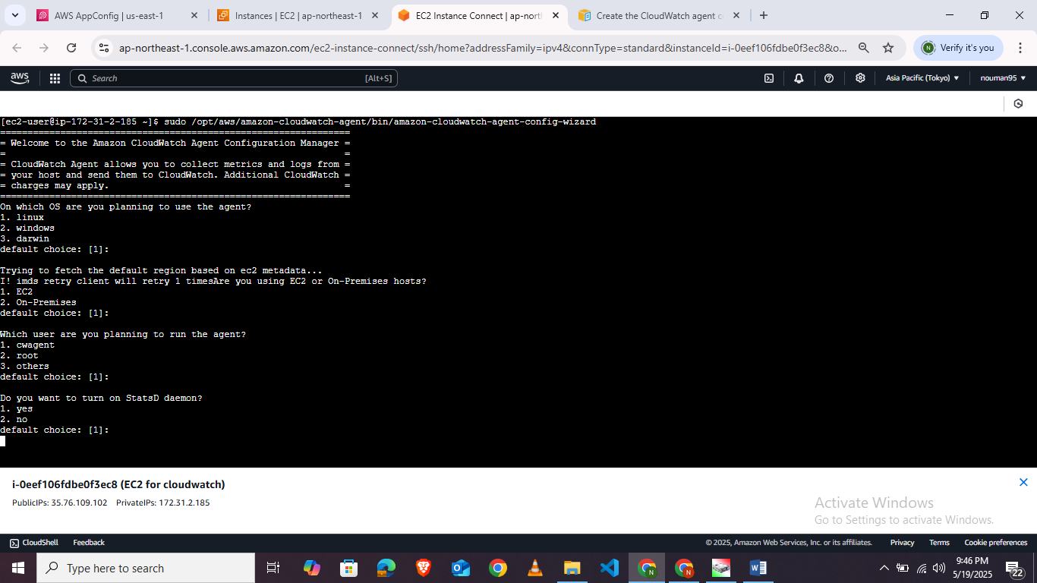
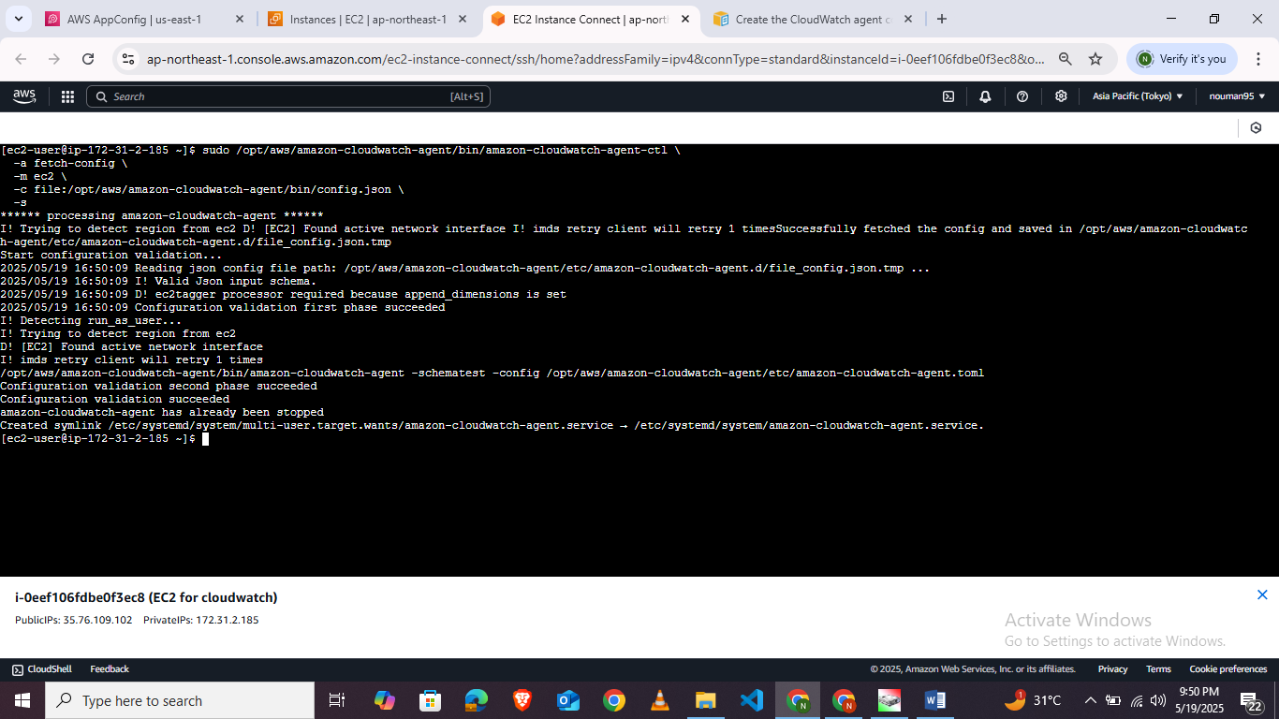
- Verify Now that the cloudwatch agent is working
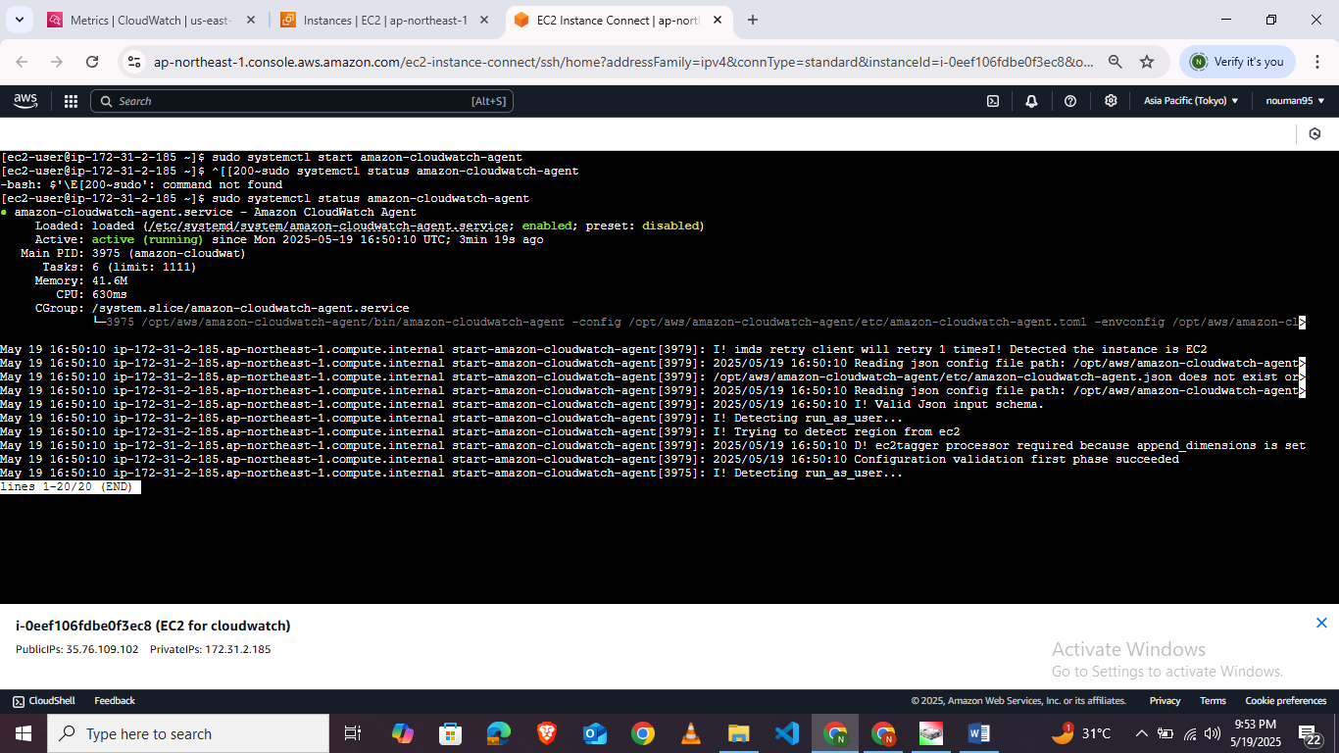
- Now go to metrics in cloudwatch select the availability zone where you hosted your EC2 instance you will find the CWAgent namespace.
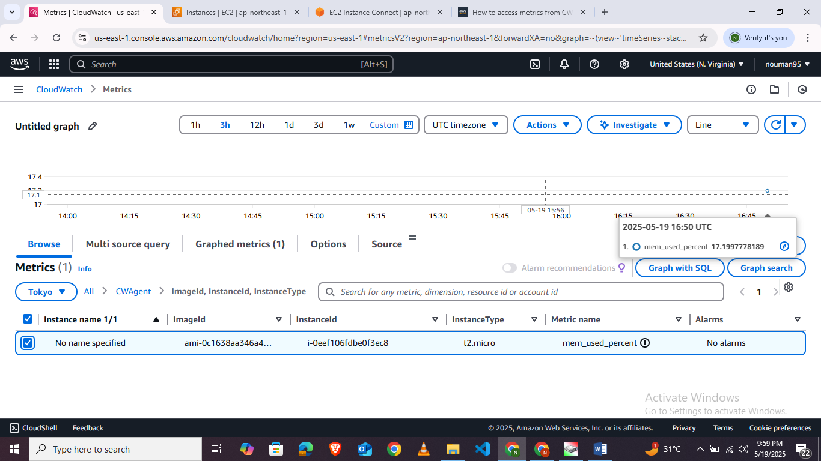
Lab Task:
Set up the CloudWatch Agent on an EC2 Linux instance to monitor system metrics (CPU, Memory, Disk) and send a custom log file to CloudWatch Logs.

